***…WOW, full !***

**Fictional Accounts of Sustainability for a Worldwide Readership**

**Digester to SDG 15.1**

**SDG 15.1 what get by MBGC ?**

**(Mini Bio Gas Continuous)**

**Digester - MBGC toward SDGs/UN 15.1**

(Target 15.1: By 2020, ensure the conservation, restoration and sustainable use of terrestrial and inland freshwater ecosystems and their services, in particular forests, wetlands, mountains and drylands, in line with obligations under international agreements)

Summary

**J W T 4**

**Bibliography/Conclusion 4**

Digester from MBGC (source) : 5

Summary – Applications (to SDGs) 7

IASR International Application Status Report 13

# J W T

### [****joules****](http://www.expotv1.com/JWT_project.pdf) [****water team****](http://www.expotv1.com/JWT_project.pdf)

[***https://www.jwt-jwt.it/***](https://www.jwt-jwt.it/)

**Subject to the NDA, consultancy and appropriate industrial property rights are available;**

( [**INNOVATION**](http://www.expotv1.com/LIC/BUNIT/LISTV.ASP) - [Patents and Projects, with relevant BPs and StartKit Commercial Offers](http://www.expotv1.com/LIC/BUNIT/LISTV.ASP)  )

**JWTeam**

<http://www.expotv1.com/ESCP_NUT_Team.pdf>

*Offers extensive support on* ***Energy*** *and* ***Water Cycle,*** *verse* [**IP_S DGs /UN**](http://www.expotv1.com/JWT_to_SDG_UN.pdf)

# Bibliography/Conclusion

Any reference to people and things is purely coincidental, as well as creative/imaginative and aimed at the common good (both in fiction and non-fiction/disclosable texts). The Owners/Inventors of the Editorial rights on the source Intellectual Property believe the contents do not misrepresent the essential objectives, aimed to disclose, but above all promote the official sources cited in the bibliographies. Patents are archived, granted and owned by authors who have issued the necessary editorial permissions. Each patent is well founded (legitimized by the relevant national legal bodies: UIBM/IT, EPO/EU, WIPO/UN, EAPO/RU, CNIPA/CN, InPASS/IN), well understandable to professionals, and usable according to case law in vogue; [**JWTeam**](http://www.expotv1.com/ESCP_NUT_Team.pdf) reviews and oversees the dissemination of [**SDGs/UN**](https://sdgs.un.org/goals), pronouncing itself with the pseudonym "**Ghost GREEN**".

# Digester from MBGC (source) :

Patent:

[**MBGC**](http://www.expotv1.com/LIC/UIBM_MBGC.pdf) ,    [**https://patentscope.wipo.int/search/en/detail.jsf?docId=WO2016092582**](https://patentscope.wipo.int/search/en/detail.jsf?docId=WO2016092582) (organic waste to biogas, for urban and periurban); [view1](https://www.bing.com/images/search?q=%28organic+waste+to+biogas%2c+for+urban+and+periurban%29&FORM=HDRSC2), [MBGC_Plan](http://www.expotv1.com/ESCP_MBGC_Plan.htm), [Hello](http://www.expotv1.com/ESCP_Hello.htm);

Italy: GRANT

<http://www.expotv1.com/LIC/MISE_0001427413_MBGC.pdf>, ...mean "INDUSTRY (useful), NEW (no make before), INVENTIVE (teach some things)"

**Abstract/Description -** Patent:

[**MBGC**](http://www.expotv1.com/LIC/UIBM_MBGC.pdf) **,**[**https://patentscope.wipo.int/search/en/detail.jsf?docId=WO2016092582**](https://patentscope.wipo.int/search/en/detail.jsf?docId=WO2016092582)

**Full Intellectual Property**

[**http://www.expotv1.com/ESCP_Patent.htm**](http://www.expotv1.com/ESCP_Patent.htm)

**Full JWTeam Service**

[**http://www.expotv1.com/PUB/JWT_Service_EN.pdf**](http://www.expotv1.com/PUB/JWT_Service_EN.pdf)

# Summary – Applications (to SDGs)

[**MBGC**](http://www.expotv1.com/LIC/UIBM_MBGC.pdf)

[**https://patentscope.wipo.int/search/en/detail.jsf?docId=WO2016092582**](https://patentscope.wipo.int/search/en/detail.jsf?docId=WO2016092582)

**Biogas - generate high purity raw materials from organic matrices. MBGC** is dedicated to the disposal and reconversion of organic waste , both from excrement (human and animal) and from manufacturing processes (agri-food industry), as well as in many agro-zootechnical activities. Very compact system that uses only renewable energy, with high energy recovery indices and production of high quality by-products (CH4, CO2, NPKx , H2O). Excellent solution for urban areas for contrast to the disposal of wastewater and containment of interventions on its infrastructures ( sewerage transport networks and purifiers ), acting in a distributive /pervasive manner where the problem arises. It offers significant contrast to the load　Organic　contributing to the performance on　" **Water cycle** ".

**Project:** MBGC – Mini Bio Gas Continuous

**Objective :** Launch a pre- assembly and testing site (procedures and manuals) for the production of MBGC tanks

**Target:** Prefabricated (CLS) companies, hydromechanics , financial investors, operators in the BioGas / BioMethane sector

The project aims to activate a production site, from design to assembly (pro delivery and rapid assembly), with the development of production-oriented procedures agreed with the client (based on the products available for supply) and destinations of the outputs produced. The solutions rely on standard products from the water management and prefabricated market, assembled and tested with a view to optimize linear anaerobic digestion, with selective and corrective extraction. In collaboration with internal and external laboratories, it will act as remote support for the installations in charge (EPC - Engineering , Procurement and Construction ).

**Summary:** This is a method for anaerobic digestion and a device for its implementation. Anaerobic digestion is a biological process that breaks down organic matter in the absence of oxygen, producing biogas, fertilizer and water. Biogas is a mixture of methane, carbon dioxide and other gases that can be used as a renewable energy source. The fertilizer is composed of nitrogen, phosphorus and potassium salts ( NPKx salts ) which can be used to enrich the soil or supplement supplies from specific industries. Water is the liquid fraction that can be reused or discharged after treatment.

A device to implement this method consists of a tank divided into different areas, where different phases of anaerobic digestion take place. The tank is equipped with bulkheads, pipes, pumps, heating means and gas separation means. The organic matter enters the tank through a vertical inlet pipe ( in homogeneous diffusion mode) and undergoes the following phases:

1) Hydrolysis: organic matter is divided into smaller molecules by means of water and enzymes;

2) Acidogenesis : the hydrolyzed products are transformed into volatile fatty acids and other compounds by acidogenic bacteria .;

3) Acetogenesis : volatile fatty acids and other compounds are further transformed into acetic acid, hydrogen and carbon dioxide by acetogenic bacteria;

4) Methanogenesis : acetic acid, hydrogen and carbon dioxide are transformed into methane and carbon dioxide by methane genic bacteria;

The liquid mixture flows through the tank from one area to another, following a path defined by the bulkheads and pipes. Along the way, some pumps recycle some of the liquid mixture to optimize the process. In the last zone, the liquid mixture separates into different components by gravity:   
a) Oleic phase: the lighter fraction which mainly contains fats and oils , is drained and brought back to the beginning;

b) Protein phase: the heavier fraction which mainly contains proteins and amino acids, not yet treated, is taken and brought to the beginning;

c) NPK salts: the solid fraction that precipitates at different levels according to their solubility and specific weight;

d) Clarified water: the clear fraction that remains after the separation of the other components is expelled by gravity and thermally pre-treated in the last part of the tank at half level;

The gases produced during the process (methane and carbon dioxide) rise towards the top of the tank, where they separate by density and start non-specific functions. Carbon dioxide, being heavier, remains in the lower part of the space above the liquid surface, while methane, being lighter, moves towards the upper part of the space. Gases are extracted through pipes with holes that are connected to gas storage or utilization systems. The device also includes a lighting and cooling system to prevent the formation of hydrogen sulfide, a toxic gas that can result in anaerobic digestion, damaging it. Lighting stimulates photosynthesis in some bacteria that consume hydrogen sulfide in the absence of oxygen. Cooling condenses water vapor in the gas phase and returns it to the liquid phase .

[***SDGs / UN_en***](https://sdgs.un.org/goals) ***-*** [***SDGs / UN_it***](https://sdgs-un-org.translate.goog/goals?_x_tr_sl=en&_x_tr_tl=it&_x_tr_hl=it&_x_tr_pto=wapp) ***Full Strategy to***

[***1***](https://sdgs.un.org/goals/goal1)[***2***](https://sdgs.un.org/goals/goal2)[***3***](https://sdgs.un.org/goals/goal3)[***4***](https://sdgs.un.org/goals/goal4)[***5***](https://sdgs.un.org/goals/goal5)[***6***](https://sdgs.un.org/goals/goal6)[***7***](https://sdgs.un.org/goals/goal7)[***8***](https://sdgs.un.org/goals/goal8)[***9***](https://sdgs.un.org/goals/goal9)[***10***](https://sdgs.un.org/goals/goal10)[***11***](https://sdgs.un.org/goals/goal11)[***12***](https://sdgs.un.org/goals/goal12)[***13***](https://sdgs.un.org/goals/goal13)[***14***](https://sdgs.un.org/goals/goal14)[***15***](https://sdgs.un.org/goals/goal15)[***16***](https://sdgs.un.org/goals/goal16)[***17***](https://sdgs.un.org/goals/goal17)[**SDGs/UN**](http://www.expotv1.com/JWT_to_SDG_UN.pdf)

[***http://www.expotv1.com/ESCP_Hello.htm***](http://www.expotv1.com/ESCP_Hello.htm)

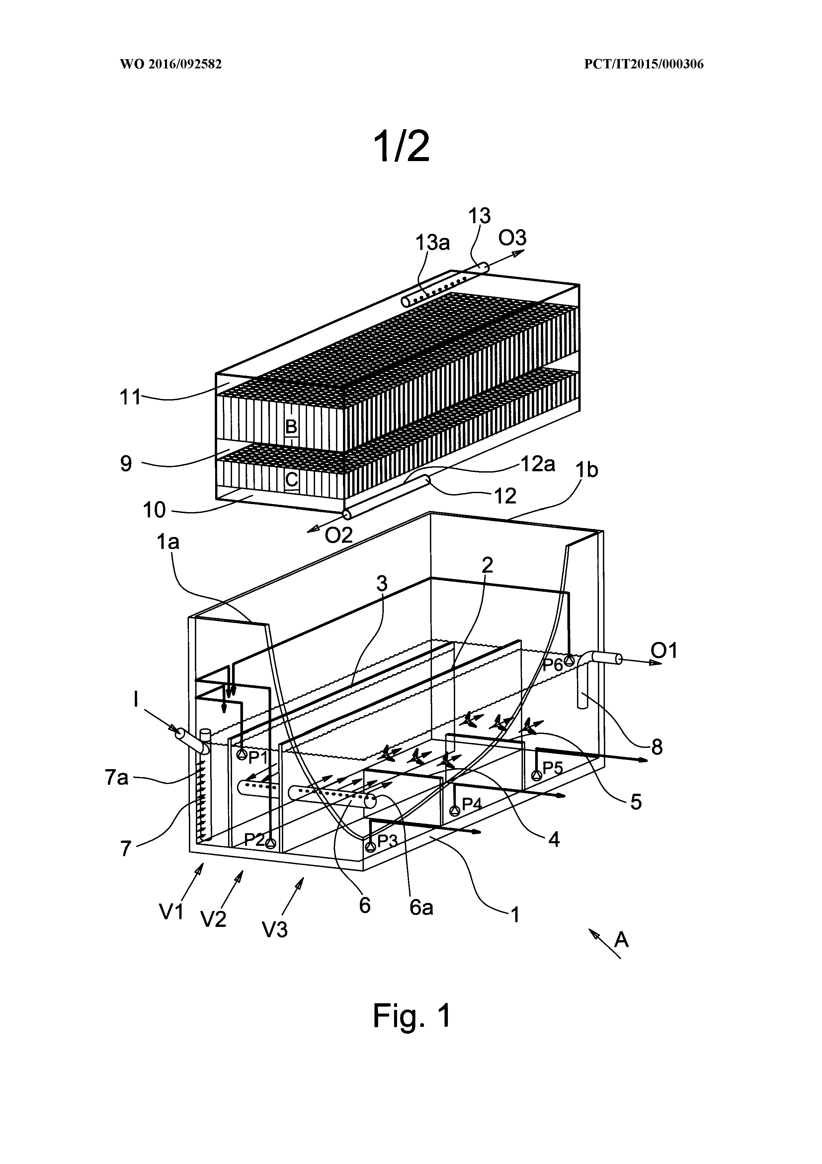

# IASR International Application Status Report

Received at International Bureau: 02 February 2016 (02.02.2016)

Information valid as of: 04 May 2016 (04.05.2016)

Report generated on: 29 September 2023 (29.09.2023)

(10) Publication number: (43) Publication date: (26) Publication language:

WO 2016/092582 16 June 2016 (16.06.2016) English (EN)

(21) Application number: (22) Filing date: (25) Filing language:

PCT/IT2015/000306 14 December 2015 (14.12.2015) Italian (IT)

(31) Priority number(s): (32) Priority date(s): (33) Priority status:

MI2014A002125 (IT) 12 December 2014 (12.12.2014) Priority document received (in compliance with PCT Rule 17.1)

(51) International Patent Classification:

C12M 1/107 (2006.01); C12M 1/00 (2006.01); C12M 1/02 (2006.01)

(71) Applicant(s):

LAVANGA, Vito [IT/IT]; Via Terrazzano 85 20017 Rho (MI) (IT) (for all designated states)

(72) Inventor(s):

LAVANGA, Vito; Via Terrazzano 85 20017 Rho (MI) (IT)

FARNE', Stefano; Via Trasimeno 40/14 20128 Milano (MI) (IT)

(54) Title (EN): METHOD FOR ANAEROBIC DIGESTION AND DEVICE FOR IMPLEMENTING SAID METHOD

(54) Title (FR): PROCÉDÉ DE DIGESTION ANAÉROBIE ET DISPOSITIF POUR LA MISE EN ŒUVRE DUDIT PROCÉDÉ

(57) Abstract:

(EN): This invention relates to a method and to a device for the implementation of said method, to decompose and to selectively extract methane, carbon dioxide, NPK salts (nitrogen, phosphorus and potassium salts) of various titre and clarified water, from an organic matrix; said components will be the raw material for further industrial processes. The method is characterized in that it includes the following phases: • implementation of a hydrolytic phase, constituted by the fission action by means of the water, by hydration; • implementation of a acidogenesis phase generated by means of specific bacteria; • implementation of a acetogenesis phase generated by means of specific bacteria; • implementation of a methanogenesis phase by means of specific bacteria, with a simultaneous gravimetric separation of a mainly oleic phase, lighter and of a predominantly protein phase, heavier; • gravimetric separation of solutions of said NPK salts of different titres • taking of clarified water. The device is characterized in that it comprises a basin (1) divided into various zones (V1), (V2), (V3), in each of which biological reactions occur, in accordance with the claimed method, said zones being all communicating and identified by suitable separation baffles, in particular: • a first baffle (2) extended from a first end (1a) of the basin to a second end (1b) of said basin (1), dividing it into two parts; • a second baffle (3), of height equal to said first baffle that divides one of said parts in a first zone (V1) and in a second zone (V2) extending from said first end (1a) of the basin (1) until it reaches the vicinity of said second end of the basin (1), so that said two zones (V1) and (V2) are communicating through an opening, of substantially vertical development, between the end of said second baffle (3) and the second end (1b) of the basin (1); • a plurality of baffles (4) and (5) transversely arranged to said first baffle (2) and inside a third zone (V3), delimited by said first baffle (2), said third zone (V3) being placed in communication with said second zone (V2) through a transfer pipe (6), positioned at about half height of said first baffle (2); • two blocks (B) and (C), placed in the upper part of said basin (1) and provided by taking means (12, 12a, 13, 13a), each of said blocks (B) and (C) including a plurality of vertical pipes and being fitted to carry out a gravimetric separation of the gases that are generated during the treatment of said mixture; said baffles (2) and (3) and said transfer pipe (6), by identifying a path crossed by the liquid mixture to be treated, that runs into the beginning of said first zone (1) where it is placed an inlet pipe (7) of the liquid mixture to be treated and comes out from various points of said third zone (V3).

(FR): La présente invention concerne un procédé et un dispositif pour la mise en œuvre dudit procédé, pour décomposer et extraire sélectivement du méthane, du dioxyde de carbone, des sels de NPK (sels d'azote, de phosphore et de potassium) de titres divers et de l'eau clarifiée, à partir d'une matrice organique; lesdits composants constituant la matière première pour d'autres procédés industriels. Le procédé est caractérisé en ce qu'il comprend les phases suivantes : mise en œuvre d'une phase hydrolytique, constituée par l'action de fission au moyen de l'eau, par hydratation; mise en œuvre d'une phase d'acidogénèse au moyen de bactéries spécifiques; mise en œuvre d'une phase d'acétogénèse au moyen de bactéries spécifiques; mise en œuvre d'une phase de méthanogénèse, au moyen de bactéries spécifiques, avec séparation gravimétrique simultanée d'une phase principalement oléique, plus légère, et d'une phase principalement protéique, plus lourde; séparation gravimétrique de solutions desdits sels de NPK de titres différents; prélèvement de l'eau clarifiée. Le dispositif se caractérise en ce qu'il comprend un bassin (1) divisé en différentes zones (V1) (V2), (V3), dans chacune desquelles ont lieu des réactions biologiques, conformément au procédé de l'invention, lesdites zones étant toutes communicantes et identifiées par des chicanes de séparation appropriées, en particulier : une première chicane (2) s'étendant d'une première extrémité (1a) du bassin jusqu'à une deuxième extrémité (1b) dudit bassin (1), le divisant en deux parties; une deuxième chicane (3), de hauteur égale à celles de ladite première chicane qui divise l'une desdites parties en une première zone (V1) et en une deuxième zone (V2) s'étendant entre ladite première extrémité (1a) du bassin (1) et le voisinage de ladite seconde extrémité du bassin (1), de sorte que lesdites deux zones (V1) et (V2) communiquent par une ouverture, de développement sensiblement vertical, entre l'extrémité de ladite deuxième chicane (3) et la seconde extrémité (1b) du bassin (1); une pluralité de chicanes (4) et (5) placées transversalement par rapport à ladite première chicane (2) et à l'intérieur d'une troisième zone (V3), délimitée par ladite première chicane (2), ladite troisième zone (V3) étant mise en communication avec ladite deuxième zone (V2) par un tuyau de transfert (6), placé à environ la moitié de la hauteur de ladite première chicane (2); deux blocs (B) et (C), placés dans la partie supérieure dudit bassin (1) et munis de moyens de prélèvement (12, 12a, 13, 13a), chacun desdits blocs (B) et (C) comprenant une pluralité de tuyaux verticaux et étant conçu pour effectuer une séparation gravimétrique des gaz qui se dégagent pendant le traitement dudit mélange; lesdites chicanes (2) et (3) et ledit tuyau de transfert (6) délimitant un trajet emprunté par le mélange liquide à traiter, qui s'étend du début de ladite première zone (1) dans laquelle est placé un tuyau d'entrée (7) du mélange liquide à traiter et sort par différents points de ladite troisième zone (V3).

International search report:

Received at International Bureau: 02 May 2016 (02.05.2016) [EP]

International Report on Patentability (IPRP) Chapter II of the PCT:

Not available

(81) Designated States:

AE, AG, AL, AM, AO, AT, AU, AZ, BA, BB, BG, BH, BN, BR, BW, BY, BZ, CA, CH, CL, CN, CO, CR, CU, CZ, DE, DK, DM, DO, DZ, EC, EE, EG, ES, FI, GB, GD, GE, GH, GM, GT, HN, HR, HU, ID, IL, IN, IR, IS, JP, KE, KG, KN, KP, KR, KZ, LA, LC, LK, LR, LS, LU, LY, MA, MD, ME, MG, MK, MN, MW, MX, MY, MZ, NA, NG, NI, NO, NZ, OM, PA, PE, PG, PH, PL, PT, QA, RO, RS, RU, RW, SA, SC, SD, SE, SG, SK, SL, SM, ST, SV, SY, TH, TJ, TM, TN, TR, TT, TZ, UA, UG, US, UZ, VC, VN, ZA, ZM, ZW

European Patent Office (EPO) : AL, AT, BE, BG, CH, CY, CZ, DE, DK, EE, ES, FI, FR, GB, GR, HR, HU, IE, IS, IT, LT, LU, LV, MC, MK, MT, NL, NO, PL, PT, RO, RS, SE, SI, SK, SM, TR

African Intellectual Property Organization (OAPI) : BF, BJ, CF, CG, CI, CM, GA, GN, GQ, GW, KM, ML, MR, NE, SN, TD, TG

African Regional Intellectual Property Organization (ARIPO) : BW, GH, GM, KE, LR, LS, MW, MZ, NA, RW, SD, SL, ST, SZ, TZ, UG, ZM, ZW

Eurasian Patent Organization (EAPO) : AM, AZ, BY, KG, KZ, RU, TJ, TM

Declarations:

Declaration made as applicant's entitlement, as at the international filing date, to apply for and be granted a patent (Rules 4.17(ii) and 51bis.1(a)(ii)), in a case where the declaration under Rule 4.17(iv) is not appropriate

Declaration of inventorship (Rules 4.17(iv) and 51bis.1(a)(iv)) for the purposes of the designation of the United States of America

